Shabbos Stories for
Parshas kedoshim 5782
Volume 13A, Issue 36 – 6 Iyar 5782/May 7, 2022
Printed L’illuy nishmas Nechama bas R’ Noach, a”h

For a free subscription, please forward your request to keren18@juno.com
Past stories can be found on the website ShabbosStories.com

Guardian of Added Life
By Rabbi Dani Staum

A neighbor related that when he informed his six-year-old son of the petirah of Rav Chaim Kanievsky, zt”l, the boy burst into tears. Through sobs, he told his father that he had wanted to ask Rav Chaim a question and now he doesn’t know who to ask. He wanted to know why we have the custom to bang when we hear Haman’s name in the Megillah, but not the two times his evil wife Zeresh is mentioned in the Megillah.
I was moved by the story because it gives a glimpse into the greatness of Rav Chaim and the profound loss we are all reeling from. It wasn’t just his unparalleled knowledge and complete mastery and clarity of all areas of Torah, it was also his care for and devotion to every single Jew of whatever background. The truth is that he would have answered such a question, no less than he would have responded to an intricate question from the greatest of scholars.
It’s well known that for years Rav Chaim would hand reply to every single letter and inquiry sent to him. This was despite the fact that it required tremendous exertion and time, both of which were so precious to him.

Referred to an Obscure Sefer
Over two decades ago I sent Rav Chaim a letter asking his opinion about a certain matter. His reply arrived a few weeks later. In small letters, he wrote with tremendous humility, “I don’t know anything more than what is written in the Sefer HaPardes (Keansburg).” He concluded with the page number.
I had never heard of the Sefer HaPardes (this was not the Sefer HaPardes attributed to Rashi), and it took me some time before I tracked down the sefer and read what the author had to say about my question.
What struck me about Rav Chaim’s response was not only the brevity and humility of it, but also that he had taken the time to reply at all.
Rav Chaim’s published seforim are extraordinary. His breadth of knowledge and clarity are apparent in his writings. He wrote about many obscure and unfamiliar sections of Torah. He published a four-volume masterful work about ze’arim, the laws connected to agriculture and planting, in the style of the Mishna Berura.
Rav Chaim also began working on a similar work on Kodshim, the corpus of laws involving the divine service in the Bais HaMikdash, including korbanos. He printed the first volume but never printed successive volumes.

Didn’t Have Time for His Own Important Publishing Projects
Reb Chaim explained that because he spent so much time replying to inquiries and meeting people each day, he didn’t have time to continue the invaluable and unprecedented work.
When told that such a work would invariably benefit future generations, Rav Chaim replied that his primary responsibility is to give chizuk [spiritual encouragement] to this current generation. He felt a responsibility to help those who sought his blessing and guidance and had to prioritize that over what could be beneficial to future generations.
It is a very telling statement. Rav Chaim gave up something precious to him and the Jewish people because he felt it was more important to give chizuk to people who needed him now.
Someone once quipped that if Rav Chaim had a nickel for every person who came to his home, he would have been well off. But he never took a red cent. He gave himself over to Klal Yisrael, old and young alike, even at the expense of his own spiritual accomplishments. Each of those meetings consumed his time and sapped his energy.

A Dikduk Question from a Young Boy
On one occasion, a family member was sitting next to Rav Chaim as he was perusing letters that had arrived that day. Rav Chaim showed his relative a letter he received from a young boy. The young boy wrote that in cheder he was learning the parsha of Miketz. When Pharaoh recounts his dreams to Yosef, he says, “Behold seven cows came up achareihen – after them.” The boy wanted to know why it says achareihen and not achareihem, which would seemingly be more appropriate in Hebrew. The boy said that he asked his rebbe but his rebbe didn’t know the answer. Therefore, he was now asking Rav Chaim.
Rav Chaim told his relative that he wasn’t sure how to reply because he didn’t think the young boy would understand the grammar rules involved. The relative suggested that Rav Chaim simply not reply. Rav Chaim explained that the reason he spends so much time replying to letters sent to him, is to give chizuk to the questioner. “I’m not sure if everyone feels chizuk from my responses, but I have no question that such a young boy will feel good about receiving a reply from me to his question.”
After a few more moments of thought, Rav Chaim smiled and wrote back that Pharaoh was in Egypt and didn’t speak Hebrew. That’s why he used incorrect grammar (Rabbi Chaim).

Never Held a Formal Position
Rav Chaim never held a formal position. He wasn’t a rav or a rosh yeshiva. On one occasion he was asked to substitute for another rebbe. Soon after he began teaching, a boy asked if he could go to the bathroom. When Rav Chaim allowed him, another boy asked if he could go out too. Then another boy asked, as another, until Rav Chaim was left with no students. He promptly got up and went home.
At the end of the day, Rav Chaim was a Jew who loved and lived Torah with every fiber of his being. He had the absolute conviction that the solution to everything, including health problems, lay in the Torah. He was the personification of the words of the Nefesh HaChaim (Sha’ar 4) that Torah is the purpose of the world and there is nothing more valuable.
In a hesped delivered about Rav Chaim, Rabbi Bezalel Rudinsky repeated a thought that Rav Lazer Shach said in a hesped he delivered about Rav Chaim’s father, the Steipler:
The Gemara (Shabbos 105b) states that anyone who is lax regarding eulogizing a Torah scholar is fitting to be buried during his life. As a case in point the Gemara notes that following the death of Yehoshua bin Nun, Moshe Rabbeinu’s successor, there was a complaint against the Jewish people, because they didn’t eulogize Yehoshua properly.

The Real Point of a Hesped (Eulogy)
How could it be that the nation failed to pay final respects to their great leader?
The point of a eulogy is to be inspired by the life and legacy of the deceased to personally grow in one’s avodas Hashem.
When Yehoshua died the nation undoubtedly spoke of his greatness, including the miracles he facilitated, such as stopping the sun and conquering 31 Canaanite nations. But those are things that the common person cannot relate to. They failed to speak about his greatness in Torah, his humility and his love for every Jew.
Those were things the nation could aspire to imitate. By not speaking adequately about them they failed to eulogize him properly. That is what the Gemara refers to as being lax in eulogizing a Torah scholar. Speaking about the scholar’s inimitable greatness that the common person cannot relate to does not motivate others to improve, and therefore fails to fulfill the objective of a eulogy.

Rav Chaim’s Knowledge was Mind-Boggling
Rabbi Rudinsky noted that Rav Chaim’s incredible greatness in Torah is far beyond what we can aspire to. The stories of his knowledge are mind-boggling, but they are largely not relatable. Therefore, if we only repeat those stories, we are not eulogizing him properly.
Rather, we should focus on his love for every Jew and the fact that he never turned anyone away. His prioritizing giving chizuk to others over his own growth is something we can relate to.
His name was Shmarayahu Yosef Chaim, which loosely translates as Guardian of Added Life. For nine decades his home was the address where all who visited felt an injection of spiritual life. We have not only lost a life, we have lost the guardian of added life. We are all mourning the irreplaceable loss. May Hashem comfort us all.

Reprinted from March 30, 2022 website of The Jewish Press.

Story #1268
Beyond Expectations
From the desk of Yerachmiel Tilles

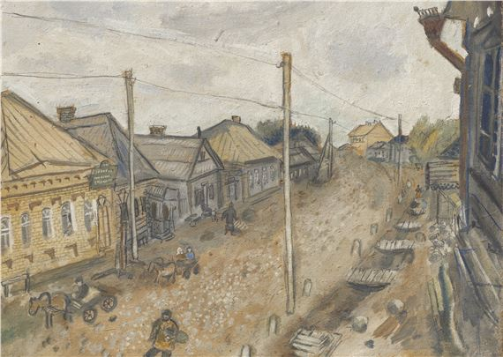
Marc Chagall’s 1914-15 painting titled Rue a Vietebsk.

The police did not give explanations. They just ordered the daughter, a young and innocent girl to accompany them. The desperate cries of the family made no difference. The police officers took the daughter and left.
The house of the girl's family was situated at the edge of the town of Vitebsk. The girl's father was a simple Jew, a blacksmith by profession. He always got up early in the morning, and joined a regular group of men for the saying of tehilim. Between Mincha (the afternoon prayer) and Ma'ariv (the evening prayer) he would attend a lecture in the book "Eyin Ya'akov" [a collection of all the non-legal sections of the Talmud]. From the morning till the evening, he stood in the smithy, working hard for his meager earnings to support his large family.
They were all in shock. The girl's parents tried to find out at the local police station what was behind the arrest of their daughter, but to no avail. Only after much effort, involving the town's influential citizens, was the situation clarified.

An Absurd Allegation that the Girl
Wanted to Convert to Christianity
It turned out that a few gentiles claimed that, in her father's smithy, they overheard the girl say that she was willing to abandon Judaism and convert to Christianity. This was an absurd falsehood, since the girl was innocent and G-d fearing. Perhaps the non-Jews had misunderstood a remark she made, or maybe they decided to invent an incident that never took place.
These men went to the town Slovda, a Christian settlement close to Vitebsk, and told to priest there that the daughter of the blacksmith wants to convert but her family is preventing her. They argued that since the girl was already eighteen years old, she wasn't subject to her parents' authority anymore and she should be allowed to do as she chooses. The priest used his connections in the police department, and officers were sent to take the girl.
Now all efforts were concentrated on trying to find out where the girl was kept. It was discovered that she was in the house of the priest in Slovda, crying constantly and begging to be allowed to go home to her family. The priest tried hard to tempt her, but she did not waver from her position.

Only One Option Available to Save the Girl
This information relieved the parents somewhat, but soon they received a worrying message. The priest had despaired of succeeding in convincing her and so it was decided to transfer her to an unknown location in the city of Orsha. Only one option to save her remained, to pay 500 rubles to a certain person.
The blacksmith immediately sold all the valuables he had in his house and managed to raise 250 rubles. He had no choice but to turn to his neighbors and ask for their help. They immediately undertook to assist him and went all out to find the rest of the money. By the end of the day, they had collected a similar sum from generous, good-hearted Jews.
As nightfall they were still 70 rubles short. The story became known in the Chabad shul (synagogue) in town. Quickly another 25 rubles were collected. Then the chasid Chaim Moshe stood up and promised to pledge another 45 rubles from the money he would earn from commissions in the coming weeks.
Chaim-Moshe Alexander was a well-known figure in Vitebsk. He was a simple Jew. Poverty reigned in his house. He was in debt over his head. The Rebbe Rayatz (Rabbi Yosef Yitzchak Schneersohn), the sixth Lubavitcher Rebbe, from whom the story is known, said that as a child he once visited Chaim Moshe at home. He lived in a dilapidated house, more like a ruin, in a side street near the river. Shocking destitution was lurking in each corner.
Chaim Moshe earned his living from brokerage businesses between dealers in cotton and the owners of the produce of the forests. This is how he lived for about twenty-two years.

Helping the Sick and Poor Even When
He Didn’t Have a Penny in His Pocket
Despite his own precarious situation, he was an extremely generous man and give a lot of charity. Even when he did not have a penny in his pocket, he would dedicate a great deal of his time taking care of the sick and poor, negotiating between the rich and the poor, who, because of his assistance, received help and support.
Everybody was astounded at the enormous amount he pledged to pay for the release of the girl. Thanks to him the whole sum was now available. The next day the good news became known, the daughter of the blacksmith was freed!
Sometime after this, a respectable merchant from the town of Smolensk came to the Rebbe Rashab (Rabbi Shalom Dovber) the fifth Lubavitcher Rebbe. The merchant was in urgent need of advice concerning his forests that were mortgaged to the bank. The Rebbe looked at him and said "My advice is that you go to the main directors of the bank, in Petersburg, and take Chaim Moshe of Vitebsk with you. He should speak to the bank managers for you."
The merchant didn't hesitate. He traveled to Vitebsk and gave Chaim Moshe the message of the Rebbe. The chasid gladly agreed and together they set out for Petersburg.

Chaim Moshe’s Personality
Charmed the Bank Manager
The bank manager was charmed by the personality of Chaim Moshe. He generously agreed to the deal Chaim Moshe's suggested. The merchant couldn't believe his ears. He never dreamed of such an agreement. He gave Chaim Moshe a generous brokerage commission of 2500 ruble!
But this was not the end of the story.
The bank manager invited Chaim Moshe and proposed to him to come be his secretary and deputy. He promised him a high salary and that the bank would arrange for him a permit of residence in Petersburg.
There and then Chaim Moshe received 5000 ruble moving expenses to Petersburg and to buy any furniture he might need. This is how Chaim Moshe the pauper became the vice president of the most respected bank in Petersburg.
In his luxurious apartment in Petersburg many charity gatherings were held, and Chaim Moshe was always the first donor. Every time he would point out that he knew the taste of poverty, penury and lack.
Also, each year, on the anniversary of the day that he signed the contract with the bank, he would gather his relatives and friends and start his story with the announcement: "I used to be poor…" At the same opportunity he would give much charity openly and secretly.

Learning Even More from
His Example as a Rich Person
The Rebbe Rayatz ended the story, "From this previously poor person one can learn a lot, but we can learn from how he was as a rich person even more."
~~~~~~~~~~~~~~
Source: Translated by C. R. Benami, long-time editorial assistant for www.AscentOfSafed.com, from the popular Israeli weekly, Sichat HaShavua (#1348). Edited and supplemented by R. Yerachmiel Tilles.
Biographical notes: Rabbi Sholom-Dovber Schneersohn 20 Cheshvan 5621 - 2 Nissan 5680 (Oct. 1860 - April 1920)], known as the Rebbe Rashab, was the fifth Rebbe of the Lubavitcher dynasty. He is the author of hundreds of major tracts in the exposition of Chasidic thought. In 1915, after 102 years of four Chabad rebbes living in Lubavitch, he transferred the center of the movement to Rostov-on-the-Don.
Rabbi Yosef-Yitzchak Schneersohn [12 Tammuz 5640 - 10 Shvat 5710 (Jan. 1880-June 1950)], known as the Rebbe Rayatz, was the sixth Lubavitcher Rebbe, from 5680 to 5710 (1920-1950). He established a network of Jewish educational institutions and Chasidim that was the single most significant factor for the preservation of Judaism during the dread reign of the communist Soviets. In 5700 (1940 C.E.) he moved to the USA, established Chabad world-wide headquarters in Brooklyn and launched a global campaign to renew and spread Judaism in all languages and in every corner of the world, the campaign that was continued and expanded so remarkably successfully by his son-in-law and successor.
Connection: Saturday night - Sunday, Nissan 2 (2022: April 3), is the 102nd yahrzeit of the Rebbe Rashab.

Reprinted from the Parshat Tazria 5782 email of KabbalaOnline.org, a project of Ascent of Safed www.ascentofsafed.com ascent@ascentofsafed.com

The Bottomless Barrel
By Hillel Baron

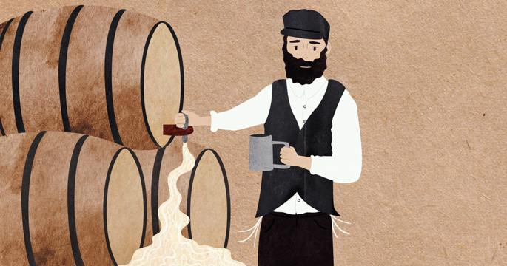
Illustration by Sefira Lightstone

A well-to-do businessman once arrived in Vienna and dispatched his servant to purchase some mead (“honey wine”) from a local, Jewish-owned tavern. He returned with a bottle, which the merchant enjoyed so much that he sent his servant out again the next day to get ten bottles of the same vintage.
The servant returned empty-handed this time, saying that the owner refused to sell him any. The businessman sent him back with even more money, but the servant returned without a single bottle for his efforts. The merchant decided to visit the tavern himself to see why there was no more mead for sale.
When he arrived, he saw a large crowd of diners reciting the Grace After Meals. When they concluded, the tavern-keeper told the merchant that his mead supply was exhausted. The merchant asked when some more would be available, to which the owner answered that it would never be available again. Seeing the visitor’s amazement, he explained:
When we were young, my wife was a midwife and I was a mohel (ritual circumciser). I would officiate at every circumcision that came my way, even if it was a long distance from home, relishing the opportunity to bring another Jewish boy into the covenant of Abraham.

The Day Before Yom Kippur
Once, on the day before Yom Kippur, a simple villager came to tell me that his wife had given birth to a boy eight days earlier, and he needed me to perform the circumcision that day. Upon learning that he lived quite a distance away, I requested that he hire a coach for the trip. He refused, claiming he had no money. I was committed, and we started off on foot together. The villager quickly outpaced me, and by the time I arrived at his home, he had already gone to work, and only the mother and the baby were home.
Now, to perform the circumcision, I needed someone to act as sandek—the one who holds the baby during the procedure. So I stood outside the humble home, hoping to find someone to fill the role.
Finally, I spotted a man hurrying past. I ran up to him and asked that he serve as sandek. He refused, saying that he was busy running from one synagogue to the next, collecting alms. Having no choice, I asked him how much he expected to net that day and made a deal with him: If he would be the sandek, he could follow me home and I would give him that amount!
The beggar agreed.
After the circumcision, we both hurried to my home with barely enough time to eat and prepare for Yom Kippur.
My family was very relieved to see me back, and I gave my last few coins to the man, expecting him to be on his way.

The Beggar was in No Hurry
But he was in no hurry, insisting that I first pour him a drink. Eager to move on with the day, I indulged him and opened a fresh keg of mead. After taking a deep draft, he wished me lechaim (“to life”) and blessed me that the barrel would not run out until the final feast celebrating my youngest son’s wedding.
And so, it was. Over the years, I have prospered from selling this never-ending supply of high-quality mead.
But just now, thank G-d, we concluded the last of the seven days of celebration for my youngest son’s marriage, and the mead just ran dry!
“A person should pay strong attention and make great efforts to uphold that which the Creator has obligated him to do as part of his service to Him to fulfill His mitzvot and to refrain from that which He has exhorted us not to do, in accordance with His requests. For then the Creator will agree to bestow on him the things for which he relies on Him.”
--Shaar Habitachon, Chapter 3, Kehot Edition, Page 76.
s
Reprinted from the Parshat Tazria 5782 email of Chabad.Org Magazine.
Chicken Wire

On Shushan Purim, my neighbor Moshe was waiting at the bus stop at a suburb of Yerushalayim for a bus going into town. As Yerushalayim residents were celebrating that day, the buses were not running on schedule. After he had been waiting almost an hour at the bus stop and no bus came by, a car stopped and offered him a ride.
There was another passenger in the car, and soon all three men were talking about the incredible hashgachah pratit involved in the story of Purim, making the point that the chain of events actually transpired over the course of nine years. With that, the other passenger said he wanted to relate a story of hashgachah pratit he had witnessed personally that had transpired in the course of a few minutes.

A Truck Loaded with Crates of Live Chickens
The storyteller had been waiting at a bus stop when a truck loaded with crates of live chickens drove by. As he watched, one chicken escaped from a crate and jumped onto the highway, a drop of about fifteen feet. The chicken landed unhurt and scurried across the highway. Cars traveling in both directions screeched to a halt, vehicles on all sides honked their horns trying to scare the chicken out of the way, and some soldiers who were also waiting at the bus stop attempted to catch the chicken.
The truck driver was serenely unaware of his passenger’s escape and the ensuing chaos on the highway. One of the soldiers did indeed catch the chicken and returned with it to the bus stop. There he stood, with a live chicken in his hands, waiting for a ride.
Out of the blue, an elderly man passed by who recognized the soldier. He stopped to see what was going on, and agreed to take responsibility for the chicken. Fortunately, he happened to be an old hand with chickens and knew that the chicken would quiet down if he tied its feet together with a piece of twine.
The traffic flow returned to normal, and the storyteller, the old man and the two soldiers began looking for something with which to tie up the chicken. The old man spotted a piece of wire in the empty lot adjacent to the bus stop. The lot was filled with building supplies, tractors and bulldozers. He started to tug at the wire, but it seemed to be stuck. The soldiers screamed at him to drop the wire immediately and back away quickly.
The piece of wire was attached to a cache of explosives hidden among the debris in the empty lot.
Baruch Hashem, this extraordinary chain of events, in the space of a few minutes, resulted in preventing a terrorist booby trap from exploding. (When the Time is Right: Stories of Divine Providence in Everyday Life by Dvora Kiel, Feldheim Publishes)

Reprinted from the Parshat Shemini 5782 email of Rabbi David Bibi’s Shabbat Shalom from Cyberspace.

The Loss of Tzaddikim

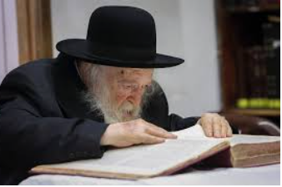

On Motzei Purim and Erev Shabbat, the entire Jewish nation suffered a great loss, with the passing of the gadol, Rav Chaim Kanievsky A’H. Reb Chaim was considered to be this generation’s most cherished scholar and halachic posek across all orthodox communities. Reb Chaim would get tens of thousands of letters in the mail and visitors each year asking him for guidance, and he almost always responded, either with his scratchy scrawl on a postcard or in-person. Though his advice was short and to-the-point, it was always sincere, and sometimes known to be confusing at first, but then miraculous.

Went to Pray in the Same Minyan with Rav Chaim
Rabbi Ran Ilan Shlita, a Rosh Kollel in Bet Shemesh, told the following story. Years earlier, a scholar from his kollel had called him at two o’clock in the morning, dejected and in tears. His young son was not feeling well, and they brought him to Hadassah Medical Center for tests. To his great despair, they found a very dangerous brain tumor in the boy, and according to doctors, his condition was hopeless. “How can I help you?” Asked the Rosh Kollel with compassion. “I want you to come with me to see Rav Chaim Kanievsky.” “Alright,” Rabbi Ilan said. “Come to my home one hour before Shacharit, and we’ll go to Bnei Brak. After praying, we’ll speak to the Rav.”
Consequently, they traveled to see Rav Chaim and explained the situation to him. “Bring the child here,” he said to them. That’s what they did, and a few hours later they both returned with the boy. As soon as the boy entered the room, Rav Chaim affectionally propped the little boy on his lap and asked him, “What do you want to be when you grow up?” “I want to be like the Rav,” he said. When he heard this, the Rav asked his wife to bring him the wine that he used for siyumim. He then served it to everyone, and they drank a l’chaim in the boy's honor. The Rav then spoke to the father, “Return to Jerusalem, to the hospital, and ask the doctors to conduct a new brain scan.” Though he was confused, the boy's father left, optimistic to see where Reb Chaim’s guidance would take him.

Asked the Doctor for a New Brain Scan
When they returned to Jerusalem, the man asked the doctor to conduct a new brain scan for his son on behalf of Rav Chaim Kanievsky. “It’s not necessary,” said the doctor. “We did one just last night. There’s no medical justification for another test, and it’s very expensive.” “No problem,” said the father. “I’ll pay all the costs, but on one condition. If the results are the same as those of yesterday, it means that the test wasn’t justified, and I’ll pay for it. However, if it shows a different result, then it was useful to have this test and therefore the hospital should pay for it.” The doctor agreed, and they conducted the test. The doctors inspected the odd results, and they wanted to check the boy again.
They took another scan, and again, miraculously, the results were completely normal. The doctors couldn’t believe their eyes! They told the father the child could leave the hospital, and from there, the boy and his father went straight to Bnei Brak to see Rav Kanievsky. When they arrived, and the Rav saw their faces beaming with joy, he said, “You certainly think that a miracle occurred here, perhaps due to the wine of the siyumim. However, there’s something you should know. When I heard that the boy wanted to become a talmid chacham, I told you to get another test done, and I remained here beseeching Hashem to have compassion on the child. I told myself that I have a duty to help, through prayer, a child who wants to become a Torah scholar. And thank G-d, my prayer was heard.”

Reprinted from the Parshat Shemini 5782 email of Rabbi Amram Sananes as written by Jack E. Rahmey.

Rav Chaim and the Chagav

The Jewish nation is in mourning over the loss of HaRav HaGaon Chaim Kanievsky, ZT”L, the undisputed leader of our generation. An incident occurred when he was writing his sefer about chagavim, a type of grasshopper/locust. Rav Chaim reached a point wherein he was distressed because he couldn’t visualize the minor differences inherent in the species, and specifically how to identify a "chagav."
Suddenly, a chagav landed in his room and he was able to carefully examine it. One of the students of Rav Chaim's adds the following - lesser known - details of the story. The student asked Reb Chaim how he knew that this particular insect was a chagav, and Reb Chaim answered that he came to this realization from its “simanim," unique physical signs.
The student heard from Reb Chaim’s wife (A”H) that a while later Reb Chaim again had a question regarding the chagav, and he was upset that he hadn’t examined the chagav for this issue when it had been placed in front of him.
Once again, a chagav landed in front of him. After Reb Chaim printed his work on this topic “Karnei Chagavim”, an expert on grasshoppers/locusts told him that he was mistaken regarding the simanim of a chagav, which caused Reb Chaim to once again become distraught and once again, a chagav landed and he was able to verify that what he had written was true.
He was so happy that he went right to his father, the Steipler Gaon, ZT"L, to tell him what had happened. The Steipler was extremely impressed with his son. About ten years ago Reb Chaim’s apartment was being renovated, a project he wasn't personally involved in. Suddenly, he jumped up and checked if the workers had broken down a certain wall. He explained that that wall was where the chagav had appeared to him, and he wished to leave the wall to remember the kindness that Hashem had done for him.

Reprinted from the Parshas Shemini 5782 email of R’ Mendel Berlin’s Torah Sweets.
----------------------------------------------------------------------------------------------------

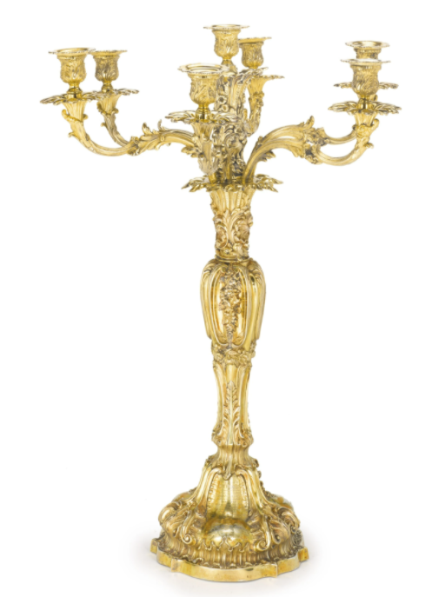
Early 19th Century (1835) silver-gilt seven-light candelabrum created by Howard & Hawksworth in Sheffield, England and sold in the 2013 Soetheby’s Judaic Auction for $46,875.

